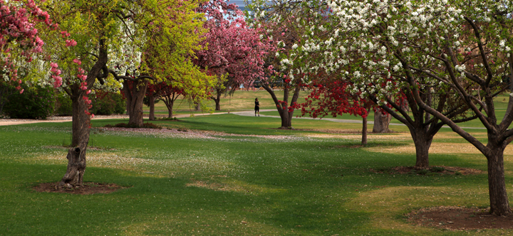
DENVER UNIT 361 - SPRING SECTIONAL
March 10-12, 2023

Arapahoe County Fairgrounds, 25690 E. Quincy Ave, Aurora, CO 80016
www.denverbridge.org

FRIDAY, MARCH 10, 2023 Lunch available for purchase
10:00 AM Beginner Pairs Single Session
10:00 AM & 2:30 PM Stratified Pairs Single Sessions
10:00 AM & 2:30 PM Bracketed Teams Double Session
10:00 AM & 2:30 PM Stratified Non-Life Master Single Sessions
(NLM) Pairs

SATURDAY, MARCH 11, 2023 Lunch available for purchase
10:00 AM Beginner Pairs Single Session
10:00 AM & 2:30 PM Stratified Open Pairs 2 Session Event
10:00 AM & 2:30 PM Stratified Open Pairs Single Sessions
10:00 AM & 2:30 PM Stratified NLM Pairs Single Sessions

SUNDAY, MARCH 12, 2023 Lunch provided with team entry
10:00 AM Bracketed Teams Play Through

Beginner Pairs: 0-20 masterpoints. No player over 20 masterpoints.
All Open and NLM Pairs: Three stratifications based on average pair masterpoints and attendance at Director’s discretion.
NLM Pairs: 0-500 masterpoints. No Life Masters. No player over 500 masterpoints.
Bracketed Teams: Stratified by average masterpoints. Top three winners in each bracket
will receive overall awards. Teams play only teams in their bracket. Brackets may be handicapped.
Friday Teams: Balanced at Director’s discretion.
Sunday Teams: 7 rounds of 7 boards. Groups of 8 depending on attendance.

Tournament Chair: Kathleen Kelly Sectional@DenverBridge.org
Partnerships: Tom Barrett Partners@DenverBridge.org
Tournament Director: tbd

Entry Fees: $12 per session for active ACBL/ABA members, $120 per Sunday team
Free play for ACBL members with 0-5 masterpoints. ACBL youth and junior (age 25 and under) discount.
Small additional fees for lapsed members. See our tournament pricing page or a tournament contact.

Denver Unit 361 Sanction Number 2303314
Scent free event – Please be considerate of your fellow players
NO ALCOHOL CONSUMPTION OR DRUGS ALLOWED

